a)

$$E_{x}=\int_{-∞}^{+∞}{{\left|x\left(t\right)\right|}^{2}dt}=\int_{-1}^{1}{{\left|1\right|}^{2}dt}+\int_{1}^{2}{{\left|-1\right|}^{2}dt}=3$$

*(Reader sketches the signal by yourself)*

b)

Sampling time: $T_{s}=1/{f_{s}}=1/{20}=0.05 (s)$

Sampled signal: $x\left[n\right]=x\left(nT_{s}\right)=4\cos\left(8π×0.05n\right)=4\cos\left(0.4πn\right)$

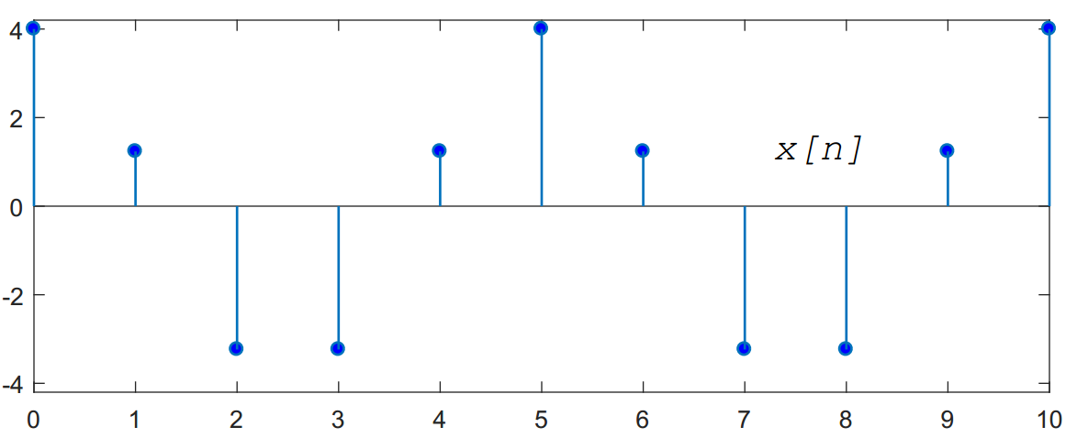

$$P_{x}=\frac{1}{N}\sum_{n=0}^{N-1}{{\left|x\left[n\right]\right|}^{2}}=\frac{1}{11}\sum_{n=0}^{10}{{\left|4\cos\left(0.4πn\right)\right|}^{2}}=\frac{96}{11}$$

Given that: $y\left(t\right)=2x\left(t\right)+x\left(2t\right)$

a) Check for linearity:

$$Let: \left\{\begin{aligned}x_{1}\underset{→}{S}y_{1}=2x_{1}\left(t\right)+x_{1}\left(2t\right) \\ x_{2}\underset{→}{S}y_{2}=2x_{2}\left(t\right)+x_{2}\left(2t\right)\end{aligned}\right.$$

$$→a_{1}y_{1}+a_{2}y_{2}=a_{1}\left(2x_{1}\left(t\right)+x_{1}\left(2t\right)\right)+a_{2}\left(2x_{2}\left(t\right)+x_{2}\left(2t\right)\right) (1)$$

Let: $x=a_{1}x_{1}+a_{2}x_{2} \underset{→}{S}y$

$$→y=2\left(a_{1}x_{t}\left(t\right)+a_{2}x_{2}\left(t\right)\right)+a_{1}x_{1}\left(2t\right)+a_{2}x_{2}(t) (2)$$

From $(1)$ and $\left(2\right)$, $a_{1}y_{1}+a_{2}y_{2}=S\left\{a_{1}x_{1}+a_{2}x_{2}\right\}$, the system is linear.

a) Check for time invariant:

Let: $x(t)\underset{→}{S}y=2x\left(t\right)+x\left(2t\right)$

$→y\left(t-T\right)=2x\left(t-T\right)+x\left(2t-2T\right)$ $(1)$ (delay the ouput).

Let: $x_{T}\left(t\right)=x\left(t-T\right)\underset{→}{S}y_{T}$

$$→y_{T}=2x_{T}\left(t\right)+x_{T}\left(2t\right)=2x\left(t-T\right)+ x\left(2t-T\right)(2)$$

Since, $\left(1\right)≠(2)$, therefore, the system is time variant.

b)

Assume that $\left|x\left(t\right)\right|≤M, M$ is finite for all $t$.

We have: $\left|y\left(t\right)\right|=\left|2x\left(t\right)+x\left(2t\right)\right|≤\left|2x\left(t\right)\right|+\left|x\left(2t\right)\right|≤2M+M=3M$

$$→\left|y\left(t\right)\right|≤3M$$

Therefore, with bounded input, the output will be bounded, which leads to the system is BIBO system.

a) Given that: $y\left[n\right]=2x\left[n\right]-x\left[n-1\right]+x\left[n-2\right]$

$$y\left[n\right]=x\left[n\right]*h\left[n\right]=\sum_{k=-∞}^{+∞}{x\left[n-k\right]h\left[k\right]}=\sum_{k=0}^{2}{x\left[n-k\right]h\left[k\right]}$$

$$=x\left[n\right]h\left[0\right]+x\left[n-1\right]h\left[1\right]+x\left[n-2\right]h\left[2\right] (1)$$

$$=2x\left[n\right]-x\left[n-1\right]+x\left[n-2\right] (2)$$

Compare $\left(1\right)$ and $\left(2\right)$, we obtain: $h\left[n\right]=\left[2, -1, 1\right]$

Given that: $x\left[n\right]=[1, 0, 2, -1, 3]$

$$+ y\left[0\right]=2x\left[0\right]-x\left[-1\right]+x\left[-2\right]=2×1-0+0=2$$

$$+ y\left[1\right]=2x\left[1\right]-x\left[0\right]+x\left[-1\right]=2×0-1+0=-1$$

$$+ y\left[2\right]=2x\left[2\right]-x\left[1\right]+x\left[0\right]=2×2-0+1=5$$

$$+ y\left[3\right]=2x\left[3\right]-x\left[2\right]+x\left[1\right]=2×\left(-1\right)-2+0=-4$$

$$+ y\left[4\right]=2x\left[4\right]-x\left[3\right]+x\left[2\right]=2×3-\left(-1\right)+2=9$$

$$+ y\left[5\right]=2x\left[5\right]-x\left[4\right]+x\left[3\right]=2×0-3+\left(-1\right)=-4$$

$$+ y\left[6\right]=2x\left[6\right]-x\left[5\right]+x\left[4\right]=2×0-0+3=3$$

Therefore, $y\left[n\right]=\left[2, -1, 5, -4, 9, -4, 3\right]$

b)

From the given $x\left(n\right)$ and $h\left(n\right)$, we have the following convolution table:

|  |  |  |  |  |
| --- | --- | --- | --- | --- |
|  | $$h_{0}=1$$ | $$h_{1}=1$$ | $$h_{2}=1$$ | $$h_{3}=1$$ |
| $$x_{0}=8$$ | $$8$$ | $$8$$ | $$8$$ | $$8$$ |
| $$x_{1}=4$$ | $$4$$ | $$4$$ | $$4$$ | $$4$$ |
| $$x_{2}=2$$ | $$2$$ | $$2$$ | $$2$$ | $$2$$ |
| $$x_{3}=1$$ | $$1$$ | $$1$$ | $$1$$ | $$1$$ |

Using this convolution table, we obtain the result:

+ $y\left[0\right]=h_{0}x_{0}=8$

+ $y\left[1\right]=h_{0}x_{1}+h_{1}x_{0}=8+4=12$

+ $y\left[2\right]=h_{0}x_{2}+h_{1}x_{1}+h_{2}x_{0}=8+4+2=14$

+ $y\left[3\right]=h_{0}x_{3}+h_{1}x_{2}+h_{2}x_{1}+h_{3}x_{0}=8+4+2+1=15$

+ $y\left[4\right]=h_{1}x_{3}+h_{2}x_{2}+h_{3}x_{1}=4+2+1=7$

+ $y\left[5\right]=h_{2}x_{3}+h_{3}x_{2}=2+1=3$

+ $y\left[6\right]=h_{3}x_{3}=1$

Therefore, $y\left[n\right]=[8, 12, 14, 15, 7, 3, 1]$

Given that:

a)

For , and $h\left(t-τ\right)$ does not overlap $→y\left(t\right)=0$.

For $t≥0$:

$$y\left(t\right)=\int_{-∞}^{+∞}{x\left(τ\right)h\left(t-τ\right)dτ}=\int_{0}^{t}{e^{-3τ}.e^{-4\left(t-τ\right)}dτ}=e^{-4t}\int_{0}^{t}{e^{τ}dτ}=e^{-4t}\left(e^{t}-1\right)$$

Thus,

$$y\left(t\right)=\left\{\begin{aligned}0 , t<0 \\ e^{-4t}\left(e^{t}-1\right), t≥0\end{aligned}\right.$$

b)

With $x_{1}\left(t\right)=e^{-3t}u\left(t\right)→y_{1}\left(t\right)=e^{-4t}\left(e^{t}-1\right)u\left(t\right)$

For $x\left(t\right)=e^{-3t}u\left(t-1\right)=e^{-3}e^{-3\left(t-1\right)}u\left(t-1\right)=e^{-3}x_{1}(t-1)$

By properties of LTI system, the output $y(t)$ is given by:

$$y\left(t\right)=e^{-3}y_{1}\left(t-1\right)=e^{-3}e^{-4(t-1)}\left(e^{t-1}-1\right)u\left(t-1\right)$$

$$Given that: \frac{d^{2}y}{dt^{2}}+10\frac{dy}{dt}+24y=6x (*)$$

a)

From $(*)$, we obtain homogeneous equation:

$$\frac{d^{2}y}{dt^{2}}+10\frac{dy}{dt}+24y=0$$

$$→D^{2}y+10Dy+24y=0$$

$$↔y\left(D^{2}+10D+24\right)=0$$

Therefore, the characteristic polynomial: $P\left(D\right)=D^{2}+10D+24$

Let: $P\left(D\right)=0↔D^{2}+10D+24=0↔D=-4 ∀ D=-6$

Thus, the natural response is:

$$y_{h}=C_{1}e^{-4t}+C_{2}e^{-6t}, C_{1},C_{2} are arbitrary constants$$

b)

For $t>0$, $(*)$ equivalent with:

$$\frac{d^{2}y}{dt^{2}}+10\frac{dy}{dt}+24y=6×8$$

Assume that the forced response has the form: $y_{p}=K→y_{p}^{'}=0→y_{p}^{''}=0$.

Substitute into the above equation:

$$0+10×0+24K=48↔K=2$$

Therefore, the total response is: $y\left(t\right)=y_{h}+y_{p}=C_{1}e^{-4t}+C_{2}e^{-6t}+2$

With the initial conditions:

$$\left\{\begin{aligned}y\left(0\right)=5 \\ y^{'}\left(0\right)=0\end{aligned}\right.→\left\{\begin{aligned}C_{1}+C_{2}+2=5 \\ -4C_{1}-6C_{2}=0\end{aligned}\right.↔\left\{\begin{aligned}C_{1}=9 \\ C_{2}=-6\end{aligned}\right.$$

Thus, the total response the system is:

$$y\left(t\right)=9e^{-4t}-6e^{-6t}+2$$